UN Human Rights Committee Says Still A Long Way To Go for Kenya

Geneva 18 July 2012. The United Nations Human Rights Committee finalized the examination of the third periodic report of Kenya on 17 and 18 July 2012.

The Human Rights Committee’s review of Kenya revolved very heavily around Kenya’s new Constitution, pending and recently enacted legislation, and the affects of these on the current state of human rights in Kenya. The delegation was pleased to report on a number of progressive reforms that align with the human rights principles enshrined in the International Covenant for Civil and Political Rights. Civil society and Kenyan NGOs were extremely well represented at the session, providing invaluable contributions to the engaging dialogue between the Committee and the State.

The Committee covered a variety of topic areas touching on anti-terrorism, justice sector reform, torture, police misconduct, LGBT, refugee and IDP issues. Specifically, it expressed concern about the State’s willingness and ability to address gross human rights violations carried out in 2007-2008, in the wake of presidential elections and in the Mt. Elgon region. It pressed the State to ensure accountability for these international crimes, and provide justice and redress to the families of victims. Particularly in light of upcoming elections, the Committee was clear that the State must take the necessary steps to prevent future violence. It specifically recommended police training on the use of force and firearms.

The Committee questioned the government on the continued practice of torture, extra judicial killings and extraordinary renditions of suspected terrorists to countries where they would be subject to persecution or torture. It further asked the delegation what measures are currently in place to provide legal aid to persons who could not otherwise afford representation, and would risk facing injustice as a result.

The Committee also focused on gender discrimination and equality, and asked the State what steps it is taking to combat the disparity among men and women in social, cultural, economic, professional and political spheres. When the Committee questioned the State’s continued sanctioning of polygamy in Kenya’s proposed marriage legislation, as set out in the Marriage Bill, 2012 and the Division of Matrimonial Property Bill, 2012, the delegation responded that this practice was one of “culture and tradition, which are the cornerstone of our civilization.”

In following up on the status of the Family and Reproductive Health Bill, the Committee noted that, though the Constitution allows abortion on some stipulated grounds, specific laws may be needed to ensure implementation. The Committee further impressed on the delegation the need for enhanced access to contraceptives, as a means of reducing unwanted pregnancy, maternal mortality and unsafe abortion.

The delegation faced questions on women’s housing rights and rights associated with access to, use of and control over land. It spoke of the Land Act, which gives both spouses equal opportunity to enjoy marital property. It also discussed the ‘two-thirds principle,’ which provides that the State will take legislative action to ensure the population of elective and appointive State bodies does not exceed a two-thirds majority of either gender. The Committee acknowledged the State’s progress in these areas, but reminded the delegation that implementation is crucial in successfully closing the gender equality gap.

Challenging the State on the issue of capital punishment, the Committee recognized that Kenya has upheld a moratorium for twenty-five years. It urged the State, however, to officially abolish the death penalty by removing it from the books – and asked the delegation when it could expect the State to commute the sentences of the 1,582 people currently on death row. The State responded it would not be able to remove the provision from legislation, stating this was “mainly as a result of cultural implications in Kenya.”

When the Committee pressed the State for additional facts on internally displaced persons in Kenya, the delegation stated that 90% of IPDs had been resettled. Information from independent sources and Kenyan NGOs, however, cast serious doubt on the accuracy of this statistic. The Committee called on the State to enact explicit provisions to prevent forced evictions.

The Committee urged the State to decriminalize same sex sexual relations among consenting adults, stating that criminalization of this kind marginalizes members of society, in turn exposing them to much greater risk. The delegation responded very firmly that the State had no intention of decriminalizing same sex activity, citing Kenyan public opinion as ‘strongly against’ this legalization.

The delegation cited culture and tradition as obstacles to more progressive improvements in several areas of human rights in Kenya. The Committee continued to hold the State accountable, however, for making these improvements – making it clear that, even in the face of what the State says is opposing ‘popular opinion,’ it cannot compromise an unwavering commitment to ensuring human rights for Kenyans.

Finally, the Committee thanked Kenya for the positive report and interactive dialogue. It reminded the delegation, however, that, “It is one thing to have a solid constitutional framework, but quite another to ensure that proper legislation, policies and institutions give those provisions effect. There is still a long way to for Kenya toward equality, accountable law enforcement systems, access to justice and many of the other human rights enshrined in the Covenant.”

The Human Rights Committee will make its recommendations public at the end of its session, on 27 July 2012. The archived webcast of Kenya’s review can be seen at treatybodywebcast.org.

For additional information on the review of Kenya contact:
CENTRE FOR CIVIL AND POLITICAL RIGHTS (CCPR):
www.ccprcentre.org / info@ccprcentre.org
(Centre for Civil and Political Rights/Ashley Tucker)
CENTRE FOR REPRODUCTIVE RIGHTS – KENYA
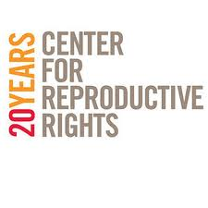
WEBSITE: http://reproductiverights.org/en/our-regions/africa/kenya
EMAIL: info@reprorights.org

FEDERATION OF WOMEN LAWYERS - KENYA (FIDA – KENYA)
Amboseli Road, Off Gitanga Road, Lavington, Nairobi | Tel: +254 (0)20 3870444 | Fax: +254 (0)20 3876372| Office Cell: 0722-509760/0733-845003
Email: info @fidakenya.org |Website: www.fidakenya.org

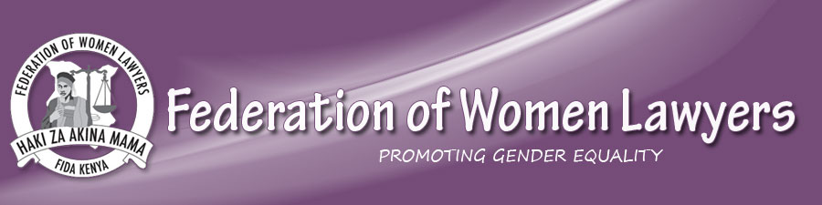

GLOBAL INITIATIVE FOR ECONOMIC, SOCIAL AND CULTURAL RIGHTS

WEBSITE: www.globalinitiative-escr.org
EMAIL: Mayra Gomez, Mayra@globalinitiative-escr.org

INDEPENDENCE MEDICO-LEGAL UNIT (IMLU)

WEBSITE: http://www.imlu.org/
EMAIL: medico@imlu.org
TELEPHONE: 020- 4450598, 0724256800

INTERNATIONAL COMMISSION OF JURISTS (ICJ – KENYA)
WEBSITE: http://www.icj-kenya.org/
EMAIL: elsy.sainna@icj-kenya.org

KENYA HUMAN RIGHTS COMMISSION

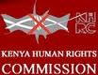
WEBSITE: http://www.khrc.or.ke/
EMAIL: admin@khrc.or.ke

TRIAL
WEBSITE: http://www.trial-ch.org/
EMAIL: daniele.perissi@trial-ch.org

UNIVERSITY OF MINNESOTA HUMAN RIGHTS PROGRAM
WEBSITE: http://hrp.cla.umn.edu/
EMAIL: hrp@umn.edu

WORLD ORGANIZATION AGAINST TORTURE (OMCT)

WEBSITE: http://www.omct.org/
EMAIL: cbb@omct.org

